Living Through Touch – Smart, Haptic Communication for Inclusion, Accessibility, and Participation

Dates: May 17-18-19, 2021
Time: 12.00 – 17.00 CET (each day)
Venue: Online via Zoom Webinaire

Recommendations to participants and accessibility features of the webinar:

1. Please remember to state your full name when logging into the webinar.

2. The programme of the event is available here: https://suitceyes.eu/program/.
An accessible version of the programme is available for download here: https://suitceyes.eu/wp-content/uploads/2021/05/A4_Programme_SUITCEYES_Symposium_accessible_format_2021_05_17.docx

3. Sign language interpretation:
International Sign Language and Brazilian Sign Language interpretation will be available during all sessions.

4. Live transcription:
Live subtitles will be available to all participants. Each participant will be able to activate subtitles, see the full transcription and customise font size of subtitles.

- Activate subtitles and view full transcript

In your meeting control bar, select Live Transcript.
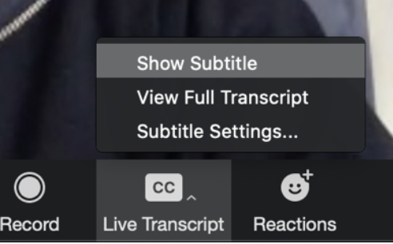

Show Subtitle will display subtitles on the screen.
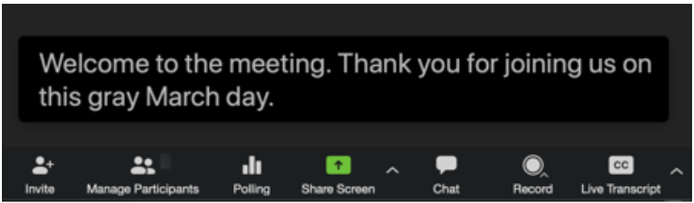
Welcome to our SUITCEYES symposium. Thank you for joining us.

View Full Transcript will display subtitles in real time in the transcript window. The speaker's name and a time-stamp will be displayed.

- Customise subtitles font size

In your meeting control bar, select Subtitle Settings.

In the accessibility menu, drag the slider to adjust font size. 